**CODE FOR PERSONALIZED MARKETING SYSTEM**

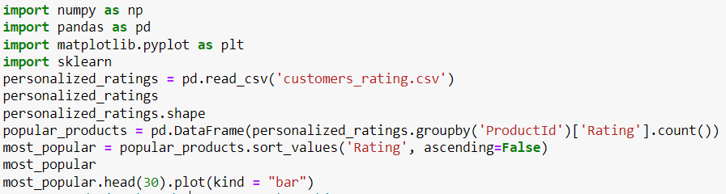

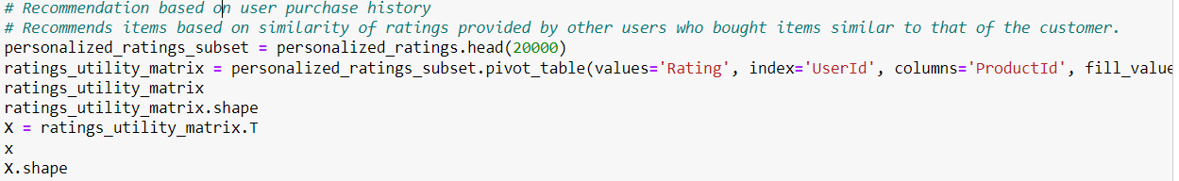

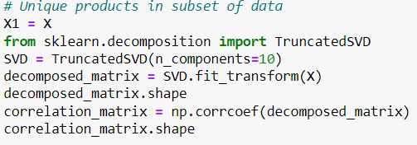

CODE FOR TESTING THE MODEL AND FINAL OUTPUT

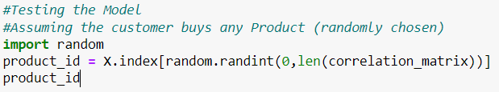

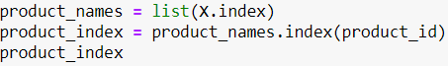



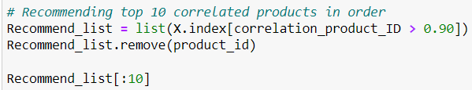

**RANDOM TESTS AND OUTPUT (LIST OF RECOMMENDED PRODUCTS):**

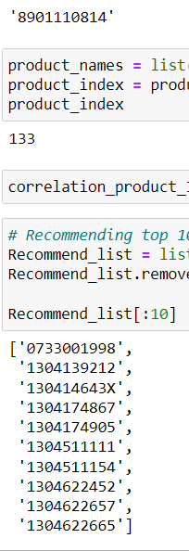 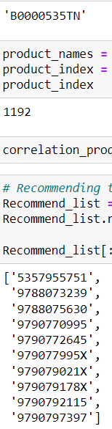 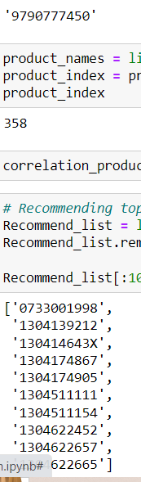

**OUTPUT BAR GRAPH AND OTHER TABLES (COMMON TO ALL TESTS USED FOR SORTING THE DATA)**

